Adam Jonathan Biggs
10311946
2022/23
__________________________________________________
RPGAI: An NLP Chatbot System for
Text-Based Role-Playing Games
__________________________________________________

Table of Contents
RPGAI: An NLP Chatbot System for Text-Based Role-Playing Games 1
Introduction 1
Background 2
Proposed System 2
Evaluation 5
Discussion 10
Conclusion 10
References 11

Introduction
A Text-Based (Play-By-Post) Role-Playing Game (RPG) is a group activity where players write their characters’ actions in text, and which often uses dice to provide an element of randomness. One well known game system is called Dungeons & Dragons which is set in a medieval fantasy world similar in theme to The Lord of the Rings fantasy series (Tolkien, 1954). In the early days of its creation Dungeons & Dragons was a simple spoken game system played in person, meaning everything is imagined like a Choose Your Own Adventure book. As technology has modernised, so has the format of such Role-Playing Games, moving online and adapting the format to better enable distant players – often in different time-zones – to play together online.
Text-Based RPGs rely on information being passed between players through text messages rather than through spoken conversation. This format of the game requires a storyteller and several players who can play whenever they are available. A back-and-forth between the storyteller describing scenes and non-player actions, and the players outlining what they want their characters to do or say takes place. This process often requires a disproportional amount of time for the storyteller compared to the players, as the storyteller will have to answer similar questions multiple times for different players and consider what information they can give to continue the storyline.
RPGAI aims to improve this process by providing research into creating a Natural Language Processing (NLP) Artificial Intelligence (AI) chatbot system to aid creating Text-Based RPGs.

Background
Several comparisons can be drawn between the RPGAI System and several existing academic projects.
Several methods (Rathod, 2018) and (Mnasri, 2019) have used general purpose NLP AI Chatbot systems with many algorithmic patterns. Implementations across the NLP field are used by many chatbot systems. NLP systems have developed from simple rule-based chatbots using lemmatization and Parts of Speech (POS) tagging into using machine learning. Though machine learning based approaches are now the dominating field for developing chatbot systems it is important to still experiment with earlier models to fully understand later ones.
Many advancements have been made for using chatbot systems for fantasy adventure games in recent years. AIDungeon (Walton, 2019) is a game which uses an AI system to determine scenes in a storyline, using a Generative Pre-trained Transformer (GPT) based neural network. The system was trained on the many thousands of short fantasy stories and text-based adventures available on the internet. Constructing a similar system would require an enormous extraction of fantasy stories from the internet with added complications if any such stories are copyrighted. In addition, RPGAI would likely overrun the scope if a similar design was chosen, evidenced by AIDungeon requiring 4 years of development to complete. Another example (Callison-Burch, 2022) relies of a corpus of thousands of Play-By-Post chat logs extracted from the D&D Beyond website, a well-known RPG forum. Whilst not used as a chatbot, the system used extraction and parsing techniques to configure unstructured data for predictive text modelling, which can inform design principles for this project.

Proposed System
The MoSCoW Analysis methodology is an effective tool for creating concise goals with measurable requirements.
Must:  - Use NLP AI to create an interactive chatbot system for Text-Based RPGs.  - Built in the Python programming language using the Natural Language Toolkit (NLTK) package.  - Use the English language. | Should  - Be immersive avoiding clunky chatbot mechanics.  - User interactions being easy to understand.  - Show experiments for a wide range of NLG techniques.
Could  - Implement sentiment analysis.  - Use RGP data crawled from websites to simulate randomised magic item generation. | Will Not  - Provide a User Interface or images.  - Generate full text-based adventures.

System Functionality & Motivation
The system requires several experiments to be conducted across a range of NLP fields. The following experiments will form the core tasks to be completed for project to be a success:
- Identity Management
- Intent Matching
- Small Talk
- Transactions
The Should and Could sections of the MoSCoW Analysis suggests further experiments could be included if time allows, which include:
- Web crawling, Information Retrieval or Question Answering
- Sentiment Analysis.

Implementation
The implementation of the RPGAI project has been separated into a workflow flowchart describing the system. In addition, consideration of the four core tasks to experiment with have been included.

Flowchart

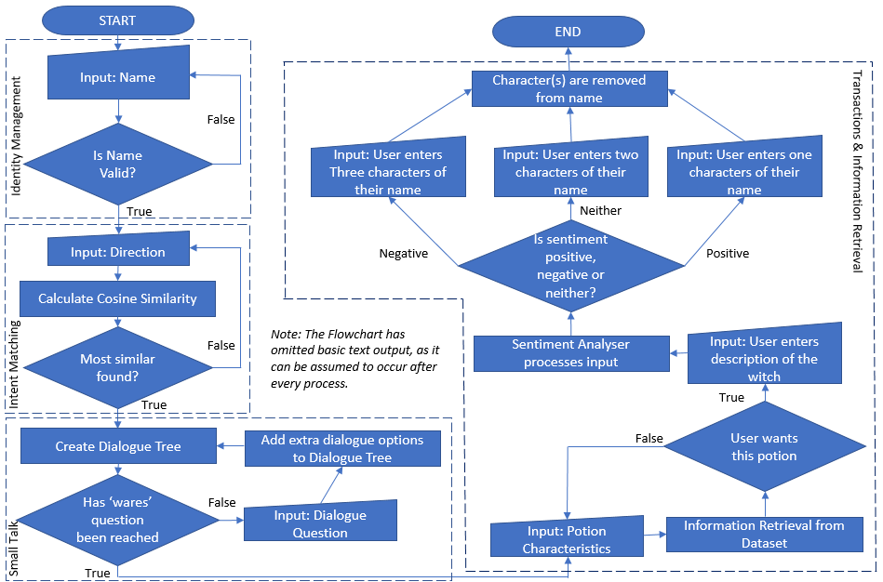

Identity Management
Experimentation began with a hacked together example of the Spacy Named Entity Recognition (NER) library (Honnibal, 2017). RPGAI replaced it with POS tagging to identify the name input. After researching further, it was found that NER systems in the past have received backlash when brought into the public space for operating without filtering offensive language (Evaluation and Discussion Sections).

Intent Matching
In a typical RPG, a story contains many similar branching paths as an illusion of choice. The second task implements such a multiple-choice system by making use of a cosine similarity calculation comparing the input with three distinctive directions.
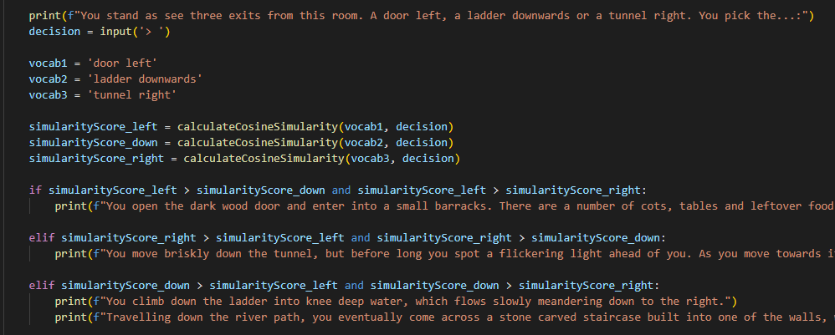

Small Talk
Multi-layered conditional dialogue trees are checked using cosine similarity. Further questions are added to the dialogue pool as new knowledge is revealed to the user.
An additional experiment uses the NLTK Sentiment Analyser to increase intractability, which is then expanded upon in the Transactions task. The user is asked to describe how beautiful the witch is for a specific dialogue; the answer being parsed through the sentiment analyser to provide reasoned responses.

Transactions
A transaction system has been implemented by bartering for a potion created from the user’s input. web crawling and Information Retrieval was used to extract random effects, appearances, and descriptions from raw data (olirant, 2015) into a potion dataset.
Cosine similarity compares the user’s requested potion characteristics with the dataset to extract the most comparable descriptions. This process simulates many randomised item generators RPGs use to increase player intractability, with non-repeating descriptive text generation being the main difficulty.
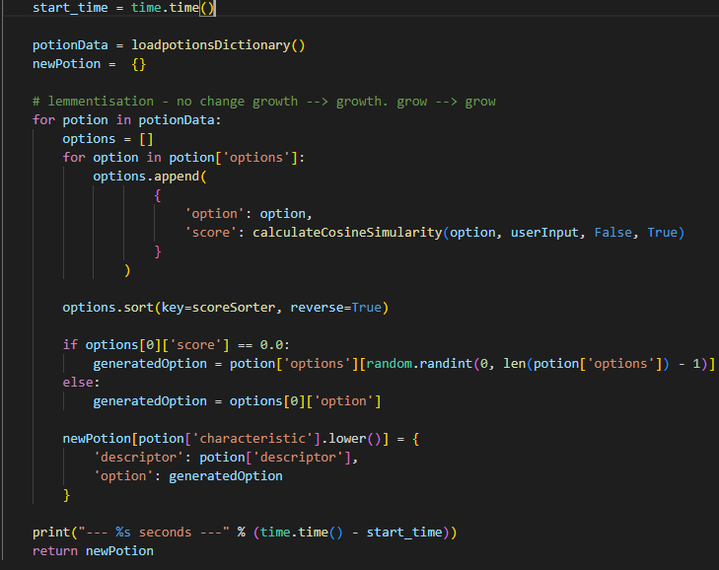
The sentiment analyser provides a basic bartering system, using the user’s name as a resource. The user describes the witch and depending on the sentiment letters are removed from their name to pay for the potion. The Identity Management system records the new name after this change.
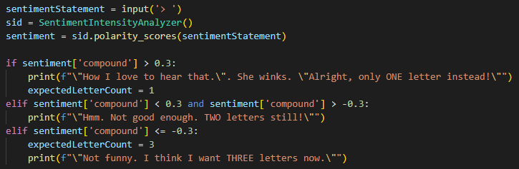

Evaluation
RPGAI has been evaluated for the MoSCoW Analysis criteria. For privacy the names of the six volunteers who tested the system have been omitted and instead replaced by unique identifiers. Each are from varied backgrounds with different understandings of Text-Based RPGs and of AI Chatbot systems.

Isolated Testing: Cosine Similarity
A core functionality of RPGAI is the Cosine similarity calculation used in comparing strings of text. The calculation must be as efficient as possible especially should the project be expanded or made public.
The calculation used was evaluated using an ablation study; the running times of a component compared when different subcomponents are added or removed. The study tests the Transactional component, when a potion is generated using user potion characteristics.
Five example potion requests were used:
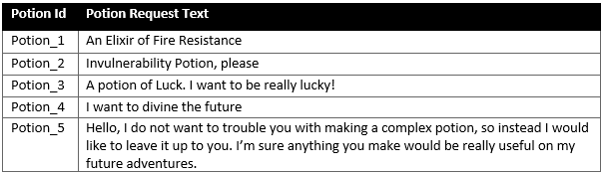
The subcomponents tested and results are shown in the table and graph below:
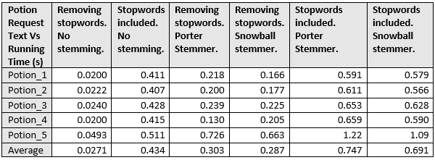

Cosine similarity compare the Potion Request Text against every characteristic in the dataset. Any additional calculations, such as by using stemming, rapidly increases the time requirement as can be seen. Stopword removal is the largest factor in improving the time as the fewer words to calculate for decreases the running time.
In addition, as the number of words in the Potion Request Text increases, so does the running time, evidenced by Potion_5 which performed the worst compared to the other more concise requests.

User Experience Testing

Overall Behaviour
Person_1 interacted with the system and their responses were recorded below.
Section | Interaction with System | Comments
1 | 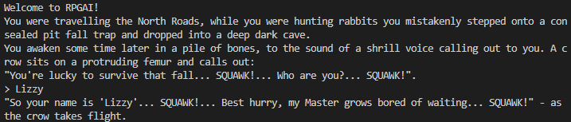 | - Liked that it recognised a nickname.  - Likes that it would work for any name ascertaining device.
2 | 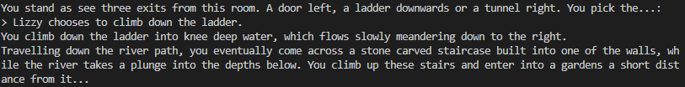 | - Liked that it works for first-person and third-person.
3 | 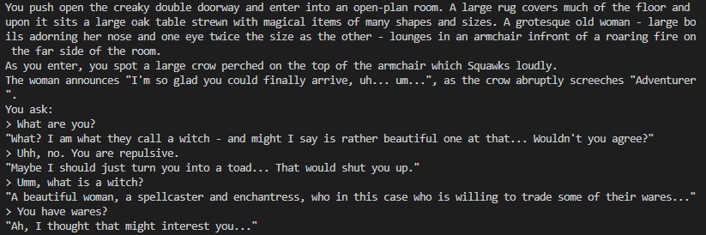 | - Good range of conversational points.  - Its sometimes gets confused between if I’m talking about the witch or the bird.
4 | 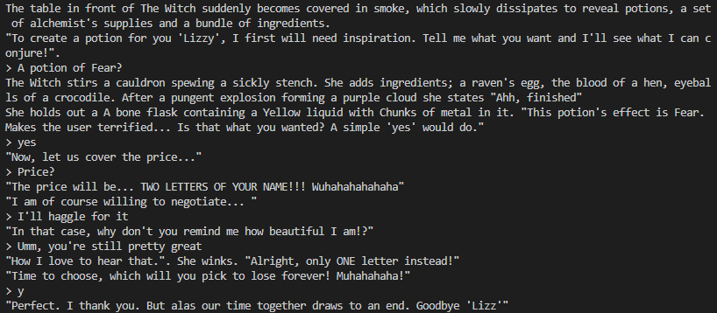 | - Liked the customisation of the potion.  - Thought the trade was immersive.  -Liked that the name was altered.

These results show that an AI Chatbot can perform Text-Based RPG interaction feasibly as an application. Many interactions from the user can be interpreted and operated on regardless of how they are described.

Dialogue-Flow Unit Testing
The dialogue-flow the chatbot was evaluated by five volunteers, using five predefined tasks based on ablation study tasks above given in a randomised order. The volunteers were asked to complete each task with as few inputs as possible.
- Ask for an elixir of fire resistance.
- Ask for a potion of Invulnerability whilst being negative in all interactions.
- Find out the name of all non-player characters.
- Barter successfully for a potion of luck.
- Receive a potion of divination.
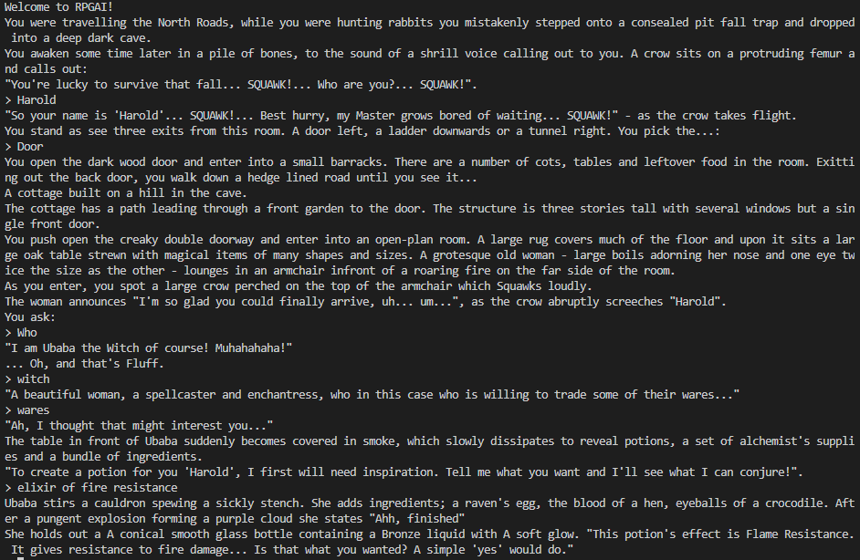
The Results are below:
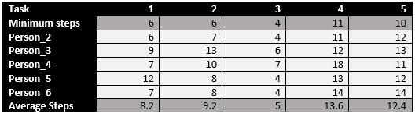

The Dialogue-Flow Unit Testing graph shows completing pathways based on specific instructions is possible to a similar number of inputs. RPGAI therefore would be a viable solution for fulfilling the requests in a Text-Based RPG as new users were able to complete tasks close to the minimum step requirement.

Grammatical Errors and Typos
The system is resistant to grammatical errors introduced from user input. The figure below shows NER and cosine similarity systems can effectively extract out meaningful text inputs even when random words are concatenated with them.
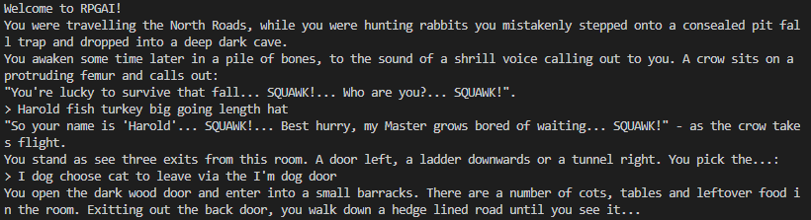
These systems preform worse when random typos are introduced into the input.
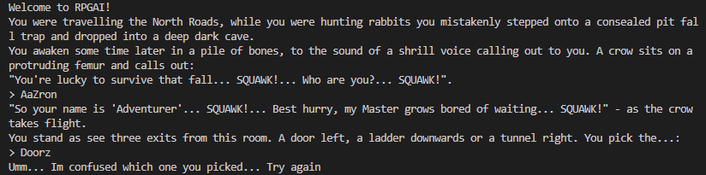
A simple fix requires unrecognised input handling. When an invalid input name is entered a default value of ‘Adventurer’ will be assigned instead. This solution is not ideal and will be considered again in the Further Work section. For the purposes of RPGAI this issue is not critical as inputs can be repeatedly entered without breaking the storylines immersion.

Discussion
The Evaluation section provides several points of discussion for potential bias in the RPGAI Project.
The Identity Management system in the Proposed System section outlined a few problems arising from the use of biased algorithms that rely on NER tagging to determine the names of users. This has also been shown publicly by the Microsoft’s AI chatbot Tay (Vincent, 2016) which used input data to determine response to Twitter tweets. When hate speech was tweeted to the bot, it included similar hate speech in its own tweets. To overcome such a problem, a whitelisting solution was introduced to replace the previous NER algorithm in the RPGAI Project. This system aims to remove potentially offensive or unwarranted language which could otherwise be entered into the chatbot system. This resolved the original issue but has now created new issues relating to potential bias in the solution.
The NLTK library contains a ‘Names’ dataset which was used to extract the first name in the user input. This dataset contains 5001 female-identifying and 2943 male-identifying names. Containing far more female-identifying names than male-identifying ones may be biased and cause tension between the sexes when new users attempt to make their character and less options are available for the male-identifying names. The owners claim the dataset is diverse and aim to avoid accusations of maintaining a biased dataset by allowing crowdsourcing for users to add new names to the dataset, although no compensation is offered for doing so. In addition, bias may be inferred by the dataset as it stores mostly English language names. The RPGAI system will not accept other names which may cause users to feel dejected by the chatbot system.
Another area of potential bias arises from utilising cosine similarity to compare the user’s input against a set of predefined expected queries. These queries were made for an English speaking and writing system, as specified in the MoSCoW Analysis. Regardless, user who find writing difficult - such as those suffering from dyslexia – or those with a low English literacy skill may not enter the key words the algorithms require and be blocked from further gameplay.

Conclusion
Overall, the RPGAI Project has been successful at fulfilling the aims created in the MoSCoW Analysis. It has provided an ample testing ground for various NLG techniques for a Text-Based Role-Playing Game AI Chatbot application.

Further Work
Further development could expand the system to allow complex sentences to be entered, for typo autocorrection to be performed and to further mitigate bias in the Identity Management system. In addition, the core system could be used to initialise other AI projects by enabling raw text to be converted into actionable instructions, for example by searching the internet for related images for a scene.
If the project was deployed in the real-world, efforts would need to be made to increase the transparency of the system for its users. The simulatability of the project would need to be publicised and the decomposability of the Identity Management and Transactions system would need to be made public, perhaps by making the project open source.

References
Bird, S. K. (2009). Natural language processing with python. O’Reilly Media.
Callison-Burch, C. a. (2022). Dungeons and Dragons as a Dialog Challenge for Artificial Intelligence. arXiv.
Honnibal, M. a. (2017). spaCy 2: Natural language understanding with Bloom embeddings, convolutional neural networks and incremental parsing. Unpublished.
Mnasri, M. (2019). Recent advances in conversational NLP : Towards the standardization of Chatbot building. arXiv.
olirant. (2015). Random Potions Table. Retrieved from reddit: https://www.reddit.com/r/DnDBehindTheScreen/comments/4btnkc/random_potions_table/
Rathod, V. a. (2018). Implementation of a Chatbot System using AI and NLP. International Journal of Innovative Research in Computer Science & Technology (IJIRCST) Volume-6, Issue-3, May-2018.
Tolkien, J. (1954). The Hobbit & The Lord of the Rings. Houghton Mifflin Harcourt.
Vincent, J. (2016, March 24th). Twitter taught Microsoft’s AI chatbot to be a racist asshole in less than a day. Retrieved from The Verge: https://www.theverge.com/2016/3/24/11297050/tay-microsoft-chatbot-racist
Walton, N. (2019). AIDungeon. Retrieved from AIDungeon: https://github.com/Latitude-Archives/AIDungeon#readme
Wolf, T. a. (2019). HuggingFace's Transformers: State-of-the-art Natural Language Processing. arXiv.

